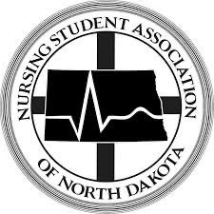

Nursing Student Association of North Dakota Convention
January 26th & 27th, 2024

Vendor/Sponsor Registration Form

Please mail form with payment to: Sara Berger
NDSU Nursing at Sanford NSA
512 N 7th Street
Bismarck, ND 58501

Organization:
Contact Person:
Address:
Phone:

Early Bird (before December 1st, 2023) Booth Price: $75
Booth Price (After December 1st, 2023): $100

Convention program booklet: Please email a JPEG file of your organization’s logo to madison.sheldon@ndsu.edu or skyy.wagner@ndsu.edu
$100 for a full page ___________
$50 for a ½ page ___________
$25 for a ¼ page ___________

Other Financial Sponsorship amount: _______________________

Door Prize available: ________________________

Total amount submitted: _________________
Payment Method: _________________
*Please make checks payable to NSAND

Thank you for supporting the Nursing Student Association of North Dakota
*Booth includes one draped 6ft long table and 2 chairs. Please let us know if you need additional items!

