NSAND Meeting Minutes 10/11/15

- Call Meeting to Order
  - Brooke motioned Alli seconds passed no opposition
- Attendance
  - President (Lindsey Stein)
    - present
  - 1st Vice President (Karen Schaff)
    - present
  - 2nd Vice President (Rachel Thorson)
    - present
  - Secretary (Alphonse Schoeneberger)
    - present
  - Treasurer (Brooke Lewton)
    - present
  - Publicity (Andrea White and Payton Borud)
    - Both present
  - Leg. Ed. (Miranda Miller)
    - present
  - Breakthrough to Nursing (Kristen Bortke)
    - present
  - Funds (Trisha Hoffart)
    - present
  - Membership (Kirby Greger)
    - present
  - Community Health (Laken Underdahl)
    - present
  - Local Arrangements (Alli Greff and Kristen Durand)
    - Both present
  - SNOY (Lindsey Holter)
    - present
  - Grad Consultants (Kayla Kaizer and Jennifer Chevalier).
    - Both present
  - Advisor (JoAnn Lindemann and Becky Brodell)
    - Not present
- Approval of Agenda
  - Alphonse motions and Kirby passed no opposition
- Approval of Last Minutes
  - Laken motioned and Alli seconds
    - passed no opposition
  - Officer Reports
  - President
    - Welcome
    - Keynote speaker update
      - All is coming together still getting in contact with people but looking good for this time in the year
  - Vice President
    - Update on vendors
      - Staple will donate all the supplies including the dots for the name tags.
      - National Guard is very willing to help and are good to go for a back-up speaker.
  - Treasurer
    - Checking-$8496.72
    - Savings-$5206.04
    - Status update on proposition for new resolution
Going to try to make sure our tax exception is set up but we are holding that for hopefully next meeting
- Old Business
  - Fundraisers
    - Touch base/ possibly finalize plans
      - Thanksgiving food drive will be discussed locally and all that needs to be reported are the numbers the food is donated locally please put your local president and advisors emails on the Facebook page ☺
  - New graduate panel discussion
    - Going with four; hopefully with different disciplines; Devin-mental health? Someone outside of working in the hospital/acute care-Jennifer, OB nurse, ask other graduate nurses that you know just in case people say no . . .
  - Fundraising booth
    - Finalize what we are going to sell
      - Lots of stuff left over from last year; t-shirts, reference cards; coffee mugs?, syringe pens?, 50/50?
  - Menu discussion
    - Going to send it out for us to see, probably going to be a taco bar? It will be on the Facebook page once it becomes available.
- New Business
  - Advertisements (Andrea/Payton)
    - Good to go
  - Registration and website
    - ??? contacted and the company didn’t know what we were talking about hopefully will hear soon
- Announcements
  - Be mindful of your specific roles, projects, and responsibilities!
- Schedule Next Meeting
  - Meeting already scheduled for November 7th in Bismarck short meeting right after the conference
- Rachel person will come to speak for the break out session
- Meeting Adjourned
  - Motioned- Lindsey Seconded- Alphonse passed no opposition

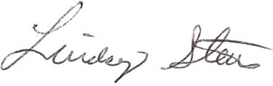 Lindsey Stein-President
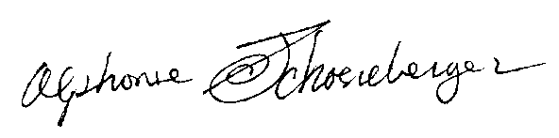Alphonse Schoeneberger--Secretary

