NSAND Meeting Minutes 3/26/15

- Call meeting to order (12:05pm)
- Attendance
  - 2015 President (Lindsey Stein)Present
    - 2014 President (Mary Pankratz)Present
  - 2015 1st Vice President (Karen Schaff)Present
    - 2014 1st Vice President (Amber Wolf) Absent
  - 2015 2nd Vice President (Rachel Thorson)Absent
    - 2014 2nd Vice President (Katie Knapp)Absent
  - 2015 Secretary (Alphonse Schoeneberger)Present
    - 2014 Secretary (Andrea Boerger)Present
  - 2015 Treasurer (Brooke Lewton)Present
    - 2014 Treasurer (Brandi Peterson)Present
  - 2015 Publicity (Andrea White and Payton Borud) Present
    - 2014 Publicity (Meaghann GraberAbsent & Kayla Kaizer Present )
  - 2015 Leg. Ed. (Miranda Miller)Present
    - 2014 Leg Ed. (Luke Lassonde)Absent
  - 2015 Breakthrough to Nursing (Kristen Bortke)Present
    - 2014 Kayden CandrianAbsent
  - 2015 Funds (Trisha Hoffart)Present
    - 2014 Funds (Ashli Foli)Present
  - 2015 Membership (Kirby Greger)Present
    - 2014 Membership (Carly Olson)Absent
  - 2015 Community Health (Laken Underdahl)Present
    - 2014 Community Health (Molly Ecker) Present
  - 2015 Local Arrangements (Alli Greff and Kristen Durand) both present
    - 2014 Local Arrangements(Kelsey Wunderlich Absent & Jennifer Chevalier-Present )
  - 2015 SNOY (Lindsey Holter) Present

  - 2015 Grad Consultants (Kayla Kaizer & Jennifer Chevalier )Present
    - 2014 Grad Consultants (Amber Kracht) Present
  - Advisors ( Joann Lindemann Absent and Becky Brodell Present )
- Approval of Agenda
  - Kayla (motioned), Alphonse (second)
- Approval of Last Minutes
  - Andrea & Ashely-all approved no oppositions
- Description of Duties
  - President
  - 1st Vice President
  - 2nd Vice President
  - Secretary
  - Treasurer
  - Publicity
  - Leg. Ed.
  - Breakthrough to Nursing
  - Funds
  - Membership
  - Community Health
  - SNOY
  - Grad. Consultants
  - Advisors
- Officer Reports
  - President
    - 2015
      - Work together and make it a fun year!
    - 2014
      - NDCN
          - Either Becky or Joann can represent NSAND at NDCN meeting; Legislative & Education (Miranda Miller) can go to the meetings also
      - Award plaques
        - Plaques are coming soon, there were a few small mistakes that is delaying the plaques.
  - Treasurer
    - 2015
    - 2014
        - Checking Balance
        - Savings Balance
- Old Business
  - Review of Bylaws
    - (all on website)
  - Conference Wrap up
    - Surveys
      - Look for surveys on Facebook; most were generally positive (Look to updating survey for items that are not relative to that specific conference; such as “how was the continental breakfast?”)
      - Also look at activities the day before conference and when speakers (time during the conference) are placed in the schedule.
      - The new board can set up conference how the new board can wish.
  - Annual tax return (Brandi Peterson)
    - This year’s needs to be completed
  - Annual Charitable Organization Report (Mary Pankratz)
    - It is in and done, but needs to be filled out each year!
  - Annual Non-profit report (Brandi/Mary)
    - It is in and done, but needs to be filled out each year!
  - NDCN mailing address (Mary Pankratz)
- New Business
  - Binders/Flash drives
    - Hopefully they are passed on to new members today (end of meeting)
  - Bank Accounts Names
    - Two people need to sign all checks (President & Treasure)
    - Remove Mary Prankratz and Brandi Peterson from bank accounts. Please add Lindsey Stein, Brooke Lewton and Kayla Kaizer to bank accounts
Karen motions to add Kayla Kaizer as advisor to bank account, Trisha seconds-all in favor, no oppositions
  - School representatives?
    - Dickinson, Minot, Williston (BSC?)
      - Secretary needs to look into it and get email out
  - Local board contact info update
  - National Convention
    - April 8th – 11th
  - 2015 Goals?
    - North Dakota board of nursing is celebrating 100th year this year; encouraged to donate an item for silent auction, individual schools can donate by going to ( . . . )
    - Come up with goal for next meeting!
  - Convention
    - Location and Logistics
      - NDNA already asking for what was planned for this coming convention. Two options for next year are Ramada Jan 21-24th pay for meals and room; Ramkoda Jan 22-24^{rth} , if guarantee a certain # of rooms (booked) we only have to pay for the meal(s).
      - Vote for placement of the conference in Ramada (Jan 21-24th) : Motion- Alli, Kristen seconds; all in favor no oppositions
  - Questions for 2014 board?
- Schedule Next Meeting
  - April 15th at 7:00pm, next meeting (use google +)
  - Think about goals (for new board) and themes for convention for next meeting.
  - Travel Reimbursement
    - Cost of travel
- Meeting adjourned
  - (1:56pm)

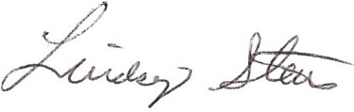 Lindsey Stein-President

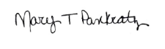Mary Pankratz—President (2014)

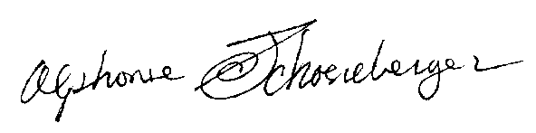Alphonse Schoeneberger--Secretary

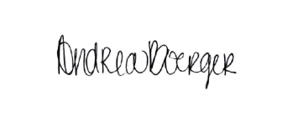Andrea Boerger—Secretary (2014)

