NSAND Meeting Minutes 4/15/14

- Call meeting to order (7:08pm)
- Attendance
  - President (Lindsey Stein)
    - Present
  - 1st Vice President (Karen Schaff)
    - present
  - 2nd Vice President (Rachel Thorson)
    - present
  - Secretary (Alphonse Schoeneberger)
    - Present
  - Treasurer (Brooke Lewton)
    - present
  - Publicity (Andrea White and Payton Borud)
    - present
  - Leg. Ed. (Miranda Miller)
    - present
  - Breakthrough to Nursing (Kristen Bortke)
    - present
  - Funds (Trisha Hoffart)
    - present
  - Membership (Kirby Greger)
    - Present
  - Community Health (Laken Underdahl)
    - present
  - Local Arrangements (Alli Greff and Kristen Durand)
    - present
  - SNOY (Lindsey Holter)
    - absent
  - Grad Consultants (Kayla Kaizer and Jennifer Chevalier)
    - Present
  - Advisor (JoAnn Lindemann and Becky Brodell)
    - present
- Approval of Agenda
- Approval of Last Minutes
  - Karen motioned and Trisha seconded-all approved no oppositions
- Officer Reports
  - President
    - Welcome
    - National Convention key points
      - Great convention all together! Go to website to see resolutions.
- Old Business
  - $7837.12 checking $5205.26 savings
  - Bank account names
    - Officially switched on April 8
  - School Representatives (Dickinson, Minot, Williston, BSC) contacted?
No but it is being worked on will be done asap
- New Business
  - Hiring someone to complete taxes
    - Laken motioned and Brooke seconded- all approved no oppositions
  - Fundraiser- “Food for Finals”
    - Two planed
    - Fill the Bus
    - No food for finals
    - Scrub drive? (possible)
      - Back to school and a Thanksgiving one
        - Alert new board next year asap about getting fundraisers going so they can have the possibility of doing a spring one.
  - Convention
    - Theme
      - Beyond average
        - Kayla motioned, Karen seconded -all approved no oppositions
    - Goals
      - Video for/of Nursing--Andrea White and Payton Borud
      - Speakers-Physician, Nurse, & Bio-ethics professor
      - Breakout sessions- Different nursing career paths (ER, and such); higher education options; maybe a new grad panel? Cluster breakouts?
  - Convention vendor discussion
Run similar as last year, maybe specifically during down time
- Schedule Next Meeting
  - Summer meeting? Yes
    - Month of July
    - July-all approved no oppositions
    - 22nd -23rd
    - in person (if possible)
      - send nursing camp info to Kristen Bortke
- Meeting adjourned
(8:14pm)
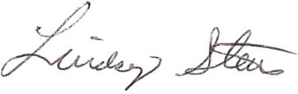-President
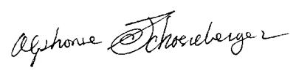-Secretary

