NSAND Agenda 12/6/15

- Call Meeting to Order 7:00pm
- Attendance
  - President (Lindsey Stein) Present
  - 1st Vice President (Karen Schaaf) Present
  - 2nd Vice President (Rachel Thorson) Present
  - Secretary (Alphonse Schoeneberger) Present
  - Treasurer (Brooke Lewton) Present
  - Publicity (Andrea White absent and Payton Borud Present)
  - Leg. Ed. (Miranda Miller) Present
  - Breakthrough to Nursing (Kristen Bortke) Present
  - Funds (Trisha Hoffart) Present
  - Membership (Kirby Greger) Present
  - Community Health (Laken Underdahl)
  - Local Arrangements (Alli Greff and Kristen Durand) Present
  - SNOY (Lindsey Holter) Present
  - Grad Consultants (Kayla Kaizer and Jennifer Chevalier) Present
  - Advisor (JoAnn Lindemann and Becky Brodell) absent
- Approval of Agenda
  - Brooke motions Alli seconds
    - passed no opposition
- Approval of Last Minutes
  - Brooke motions Alli seconds
    - passed no opposition
- Officer Reports
  - President
    - Welcome
    - Comments on NDNA meeting
  - Treasurer
    - Checking-$9496.24
    - Savings-$5206.04

- Old Business
  - Fundraising
    - T-shirt designs.
      - Check on our facebook to vote on which one you would want!
    - Reference card requests for local chapters
  - Publicity
    - Advertising for State
      - Andrea coming up with logo and video should be done pretty soon; for the video we might ask people video record on phone?
    - Logo for State? (Andrea) (is working on it)
  - Leadership/SNOY
    - Judges (still looking for two hopefully will soon)
  - Local Arrangements
    - Menu taco bar for lunch, pasta bar for dinner with a gluten free option?
    - Contacted Belinda about Jan. 16th? She will hopefully meet with us then
- New Business
  - Advisor Discussion (refer to bylaws)
    - If anyone has a professor that they feel would be a good advisor please ask them
    - Maybe send out emails to schools and extend an offer
    - Three year term
  - NDNA Members at State
    - 7 members at the convention
  - Vendor fee/ registration fee?
    - Table until next meeting register as normal if we vote through that board members don’t need to pay we will be refunded
    - 4 that have paid still working on a few more
  - Review of Schedule
    - Keynotes
    - Meeting/ Board member breakout
    - Other details
- Announcements
  - Be mindful of your specific roles, projects, and responsibilities!
- Schedule Next Meeting
  - Potentially already scheduled for January 16th
- Meeting Adjourned
  - Kirby motioned and Alli seconded
    - passed no opposition
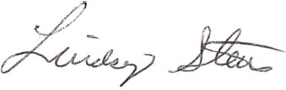 Lindsey Stein-President
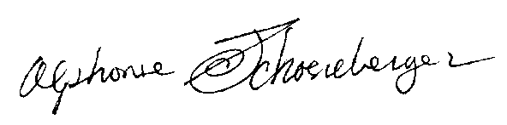Alphonse Schoeneberger--Secretary

