NSAND
ANNUAL BUSINESS MEETING SCRIPT – Day Two Part 1

- Call to Order by President at 8:30 am.
- Roll Call:
  - President (Lindsey Stein) Present
  - 1st VP (Karen Schaaf) Present
  - 2nd VP (Rachel Thorson) Present
  - Secretary (Alphonse Shoeneberger) Present
  - Treasurer (Brooke Lewton) Present
  - Director - Breakthrough to Nursing (Kristen Bortke) Present
  - SNOY- (Lindsey Holter) Present
  - Director of Funds (Trisha Hoffart)
  - Director of Membership (Kirby Greger) Present
  - Director of Legislative Education (Miranda Miller) Present
  - Director of Community Health (Laken Kittleson) Present
  - Director of Publicity and Communications (Andrea White and Payton Borud) Present
  - Local Arrangements (Kristen Durand and Alli Greff) Present
  - Graduate Consultant (Kayla Kaiser and Jennifer Chevalier) present (Jennifer absent)
  - Advisors (JoAnn Lindeman) Present
- Establish Quorum:
  - There are___123____NSAND members present. The President is present. NSAND has defined quorum by stating the Annual Meeting shall consist of members from at least 51% of the total number of members credentialed at the Annual Meeting and which represent at least 2/3 of the schools having members credentialed the Annual Meeting and at least four members of the Board of Directors, including the President or First Vice President. The number needed for a majority vote is____63____ and the number for 2/3 vote is___81___.
- Announcements
- Approval of Agenda:
  - Motion by (Laken Kittleson)
  - Second by (Kristen Bortke)
- Candidate Introductions and Speeches:
  - President
  - 1st VP
  - 2nd VP
  - Secretary
  - Treasurer
  - Director-Breakthrough to Nursing
  - Director of Funds
  - Director of Membership
  - Director of Legislative Education
  - Director of Community Health
  - Directors of Publicity and Communications
  - Director of Local Arrangements
  - Graduate Consultant
  - Advisors
- Voting
- Motion to destroy ballots after New Board is announced Rachel Thorson
  - Second: Trisha Hoffart
- Motion by Alli Greff to recess business meeting until 11:00am, Saturday, January 30th, 2016
  - Second: Kristen Durand

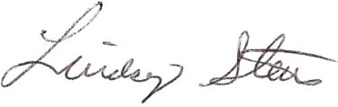 Lindsey Stein-President
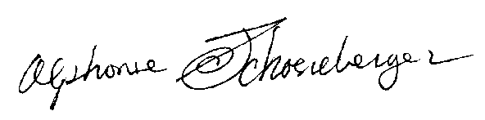Alphonse Schoeneberger--Secretary

